COM7033 – Secure Software Development
Software Artefact Report
Student Name: Chinemerem Magnus Okoh
Student ID: 2514965
Module Leader: Dr Antesar Shabut
Introduction
Digital healthcare systems are important in modern healthcare because they support patient management, clinical decisions, and administrative processes. These systems handle sensitive medical data, so they must be designed with strong security measures to protect confidentiality, integrity, and availability (Anderson, 2020).
In this project, the focus is on developing a simple, secure web healthcare system for managing patient records. The system allows users to register, log in, and manage patient information like name, age, diagnosis, and treatment. The purpose of this project is to apply secure software development practices throughout the development process.
The system was developed using Python and the Flask framework, with SQLite used as the database. Security features such as password hashing, session management, and input validation were added to protect user data and prevent unauthorised access.
In addition, the development process followed key principles of the Secure Software Development Life Cycle (SSDLC), making sure that security was considered at each stage of the system development.
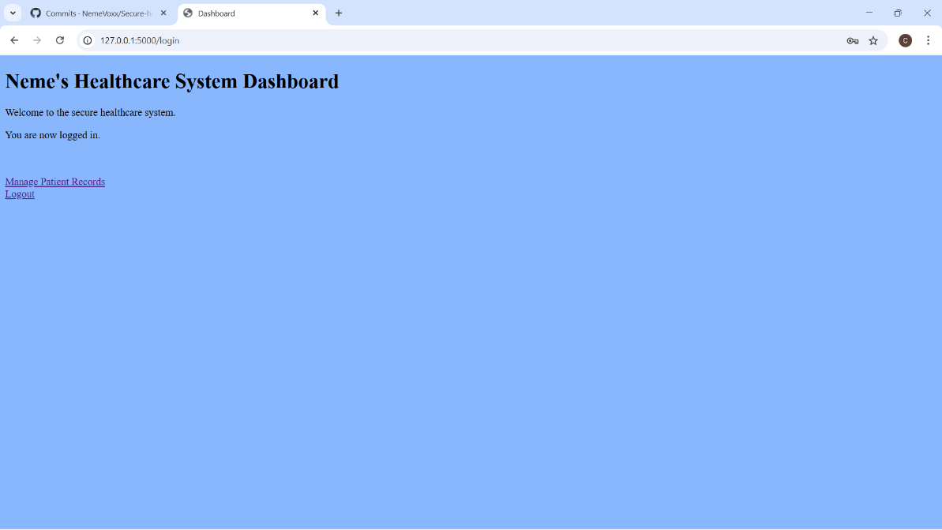

Requirements Analysis

This system was designed as a simple healthcare web application for managing patient records. It allows users to register, log in, and perform operations like adding, viewing, editing, and deleting patient information. The main aim of the system is to provide a basic but secure way of storing and managing patient data. Since healthcare systems deal with sensitive information, security must be considered from the beginning of the development process.

Stakeholder Identification
In this system, the main user is the person managing patient records. This user logs into the system and performs actions such as adding, editing, and deleting patient data. Patients are also important in this system because their personal and medical data are stored. Even though they do not directly use the system, their data must be protected every time.
In a more secure healthcare system, there would be other roles, such as clinicians and administrative staff. These roles would have different levels of access. Although this system is simple, it still shows the need to control access to sensitive information.
Functional Requirements
The system must support the following basic functions:
- Users must be able to register
- Users must be able to log in securely
- Users must be able to add patient records
- Users must be able to view patient records
- Users must be able to edit patient details
- Users must be able to delete patient records
- The system must restrict access to authorised users only
In addition, based on a typical healthcare system, different types of users would have different responsibilities.
Patients would normally be able to view their own records and personal information. Clinicians would be responsible for creating and updating patient medical data, such as diagnosis and treatment. Administrative staff would manage system users and ensure that records are organised properly. In this project, the system uses a single user role for simplicity. However, it still reflects the idea that access should be controlled. In a more secure system, role-based access control would be implemented to separate patients, clinicians, and administrators.

Security Requirements
Because the system handles sensitive healthcare data, security is very important.
The system must:
- Make sure that only logged-in users can access the system
- Protect passwords using hashing
- Prevent unauthorised access to patient data
- Validate user input to reduce errors and attacks
- Manage user sessions securely
According to the General Data Protection Regulation (GDPR, 2018), personal data must be processed securely and protected against unauthorised access. This means that systems handling healthcare data must include proper security controls.
Data Sensitivity
The system stores patient information such as:
- Name
- Age
- Diagnosis
- Treatment
This type of data is sensitive because it relates to a person’s health. If this data is exposed, it can lead to privacy issues. For this reason, the system uses authentication and access control to help protect patient data. In a more secure system, additional measures such as encryption and role-based access control would be added.
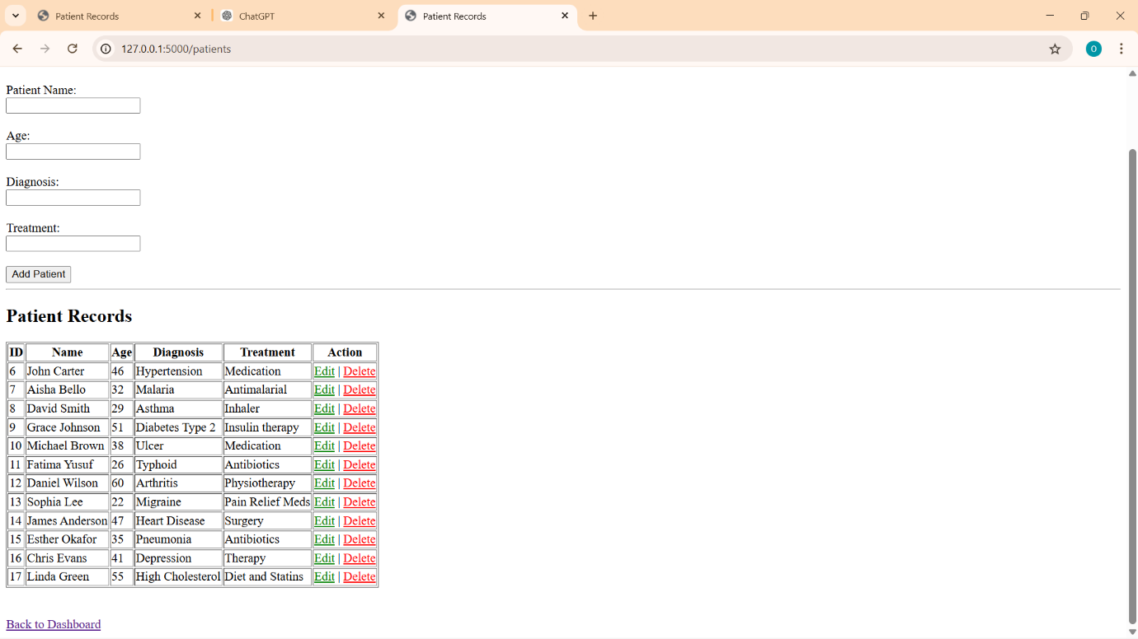

Threat Modelling
In secure software development, it is important to identify possible security threats before and during system design. This helps in reducing risks and protecting sensitive data. In this project, the STRIDE model is used to identify possible threats. STRIDE stands for Spoofing, Tampering, Repudiation, Information Disclosure, Denial of Service, and Elevation of Privilege. This approach helps to understand how the system could be attacked and what security measures are needed.
- Spoofing: This happens when an attacker pretends to be a legitimate user. In this system, an attacker could try to log in using another user’s credentials. To reduce this risk, the system uses login authentication with usernames and passwords. Passwords are stored using hashing, which makes them harder to steal. In a more secure system, additional protection such as multi-factor authentication could be used.
- Tampering: This refers to unauthorised modification of data. In this system, an attacker may try to change patient records, such as diagnosis or treatment details. To reduce this risk, the system restricts access to logged-in users and validates input before storing data. In a more secure system, logging and audit trails would be added to track all changes made to patient records.
- Repudiation: This occurs when a user denies performing an action. For example, a user may edit or delete a patient record and later deny it. Currently, the system does not fully track user actions. In a more secure system, logging would be implemented to record actions such as login, updates, and deletions. This would provide accountability and traceability.
- Information Disclosure: This happens when sensitive data is exposed to unauthorised users. This is a major risk in healthcare systems because patient data is highly sensitive. In this system, access is restricted using login authentication. However, in a more secure system, data encryption and stronger access control would be implemented. According to GDPR (European Union, 2018), personal data must be protected from unauthorised access.
- Denial of Service: This occurs when an attacker tries to make the system unavailable. For example, repeated login attempts could overload the system. The current system is simple and does not include full protection against this. In a more secure system, rate limiting and monitoring would be used to prevent such attacks.
- Elevation of Privilege; This happens when a user gains access to functions they are not allowed to use. In this system, all users have similar access once logged in. This can be a limitation. In a more secure system, role-based access control (RBAC) would be added to make sure that users can only access what they are allowed to.
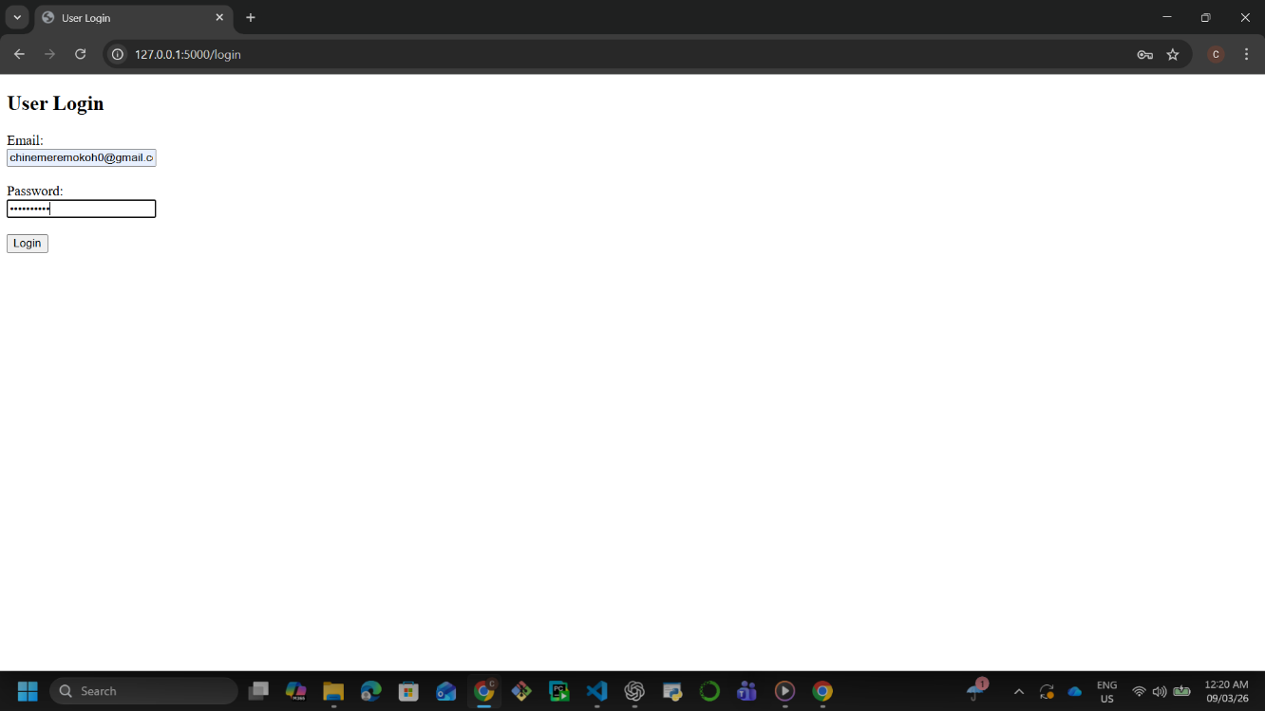

System Architecture
This system was designed as a simple web-based application using the Flask framework. It follows a basic structure where users interact with the system through a web browser, and requests are processed by the application before being stored in a database.
The system consists of three main parts:
- User Interface: This includes the web pages such as login, register, dashboard, and patient management pages. Users interact with the system through these pages.
- Application Layer (Flask): This handles the logic of the system, including authentication, routing, and processing user requests.
- Database (SQLite): The database is used to store user information and patient records.
This structure helps to separate different parts of the system, making it easier to manage and improve security.

Secure Design Considerations
Security was considered during the design of the system. Users are required to log in before accessing the dashboard or patient records. This helps to prevent unauthorised access to sensitive data. The system also ensures that sensitive operations such as adding, editing, and deleting patient records can only be performed by logged-in users. Input validation is used to reduce the risk of incorrect or harmful data being entered into the system.

Secure Design Principles
The system follows basic secure design principles:
- Confidentiality: Patient data is only accessible to authorised users.
- Integrity: Data is protected from unauthorised changes through input validation and controlled access.
- Availability: The system allows authorised users to access patient data when needed.
These principles are important in healthcare systems where data must always be protected (Anderson, 2020).

Improvements for a More Secure System
Although this system includes basic security features, a more secure healthcare system would include:
- Role-based access control (different user roles)
- Encryption of sensitive data
- Multi-factor authentication
- Secure communication using HTTPS
- Separation of authentication data from patient data
For example, a more advanced system could use a different database such as MongoDB to store patient data separately from user credentials.
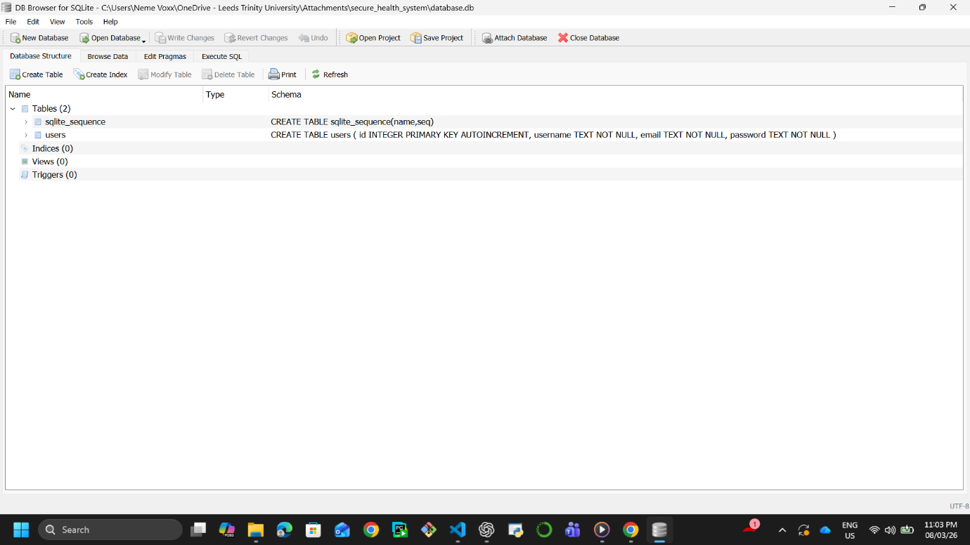

Implementation
This system was developed using a step-by-step approach, starting from setting up the development environment to building the main features of the application. Security was considered during development, not just at the end. This follows the idea of the Secure Software Development Life Cycle (SSDLC), where security is included throughout the development process.
This system was developed using the following technologies:
- Python (Flask Framework): Flask was used to build the web application and handle routing, user requests, and system logic.
- SQLite Database: SQLite was used to store user data and patient records. It is simple and suitable for small applications.
- Werkzeug Security: This was used to hash passwords before storing them in the database.
These technologies were chosen because they are easy to use and support secure web development.
Authentication System
This system includes a login and registration feature. Users must register with a username and password and then log in before accessing the system. Passwords are not stored as plain text. Instead, they are hashed using a secure method. This helps to protect user credentials in case the database is accessed by an unauthorised person. Authentication is important in healthcare systems because it prevents unauthorised access to sensitive patient data.

Patient Record Management (CRUD)
This system allows users to perform the following operations on patient records:
- Add new patients
- View patient records
- Edit patient details
- Delete patient record
These operations were added using Flask routes and forms. Access to these features is restricted to logged-in users. This helps to protect patient data from unauthorised access.

Input Validation
This system checks user input before storing it in the database. This helps to reduce errors and prevent simple attacks such as entering invalid data. Input validation is an important part of secure coding because it helps protect the system from unexpected or harmful input.

Session Management
This system uses session management to keep users logged in. When a user logs in successfully, a session is created. This session is used to control access to protected pages such as the dashboard. If a user is not logged in, they cannot access these pages. Session management helps maintain security by ensuring that only authenticated users can access the system.
Limitations and Future Improvements
Although the system includes basic security features, there are some limitations. For example, all users currently have the same level of access. In a more secure system, role-based access control would be added to separate users such as clinicians and administrators. Also, the system does not currently use encryption for stored data. In a more secure healthcare system, encryption would be necessary to further protect sensitive information.
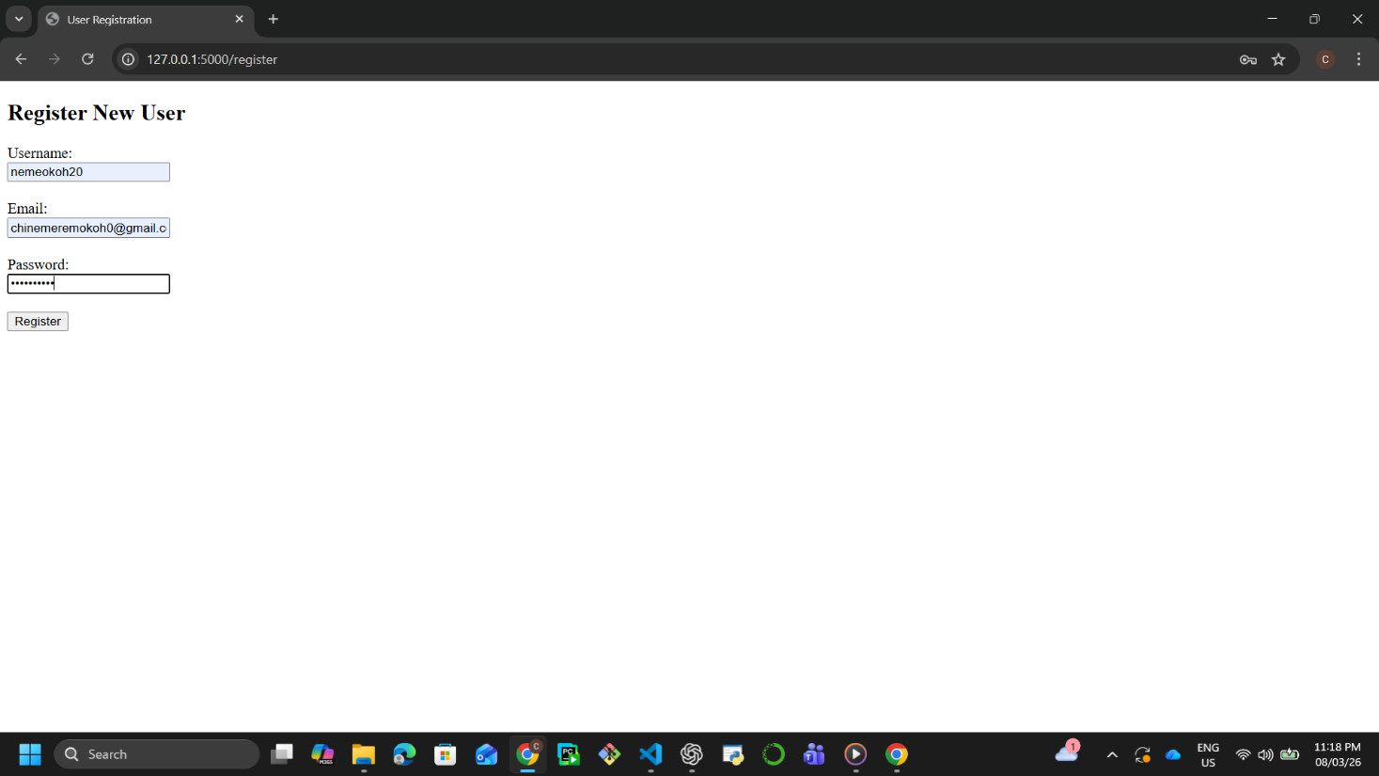

Testing
Testing was carried out to make sure that the system works correctly and that basic security controls are effective. Both functional testing and simple security testing were performed. The aim was to check that the system behaves as expected and that unauthorised access is restricted.

Functional Testing
The main features of this system were tested to confirm that they work properly. The following tests were carried out:
- User registration was tested by creating a new account
- User login was tested using the correct login details
- Patient records were tested by adding new patients
- Editing patient details was tested
- Deleting patient records was tested
All these functions worked as expected when valid inputs were provided.

Failed Test Cases
Some tests were carried out to check how the system behaves when incorrect input is provided.
- Login with incorrect username or password was tested
→The system denied access
- Submitting empty form fields was tested
→ The system did not process invalid input properly in some cases
These tests show that the system can prevent unauthorised access, but input validation can be improved.

Security Testing
Basic security testing was carried out based on possible threats identified earlier.
- Attempt to access the dashboard without logging in
→ Access was restricted
- Attempt to log in with incorrect credentials
→ Access was denied
- Attempt to perform actions without authentication
→ System prevented access
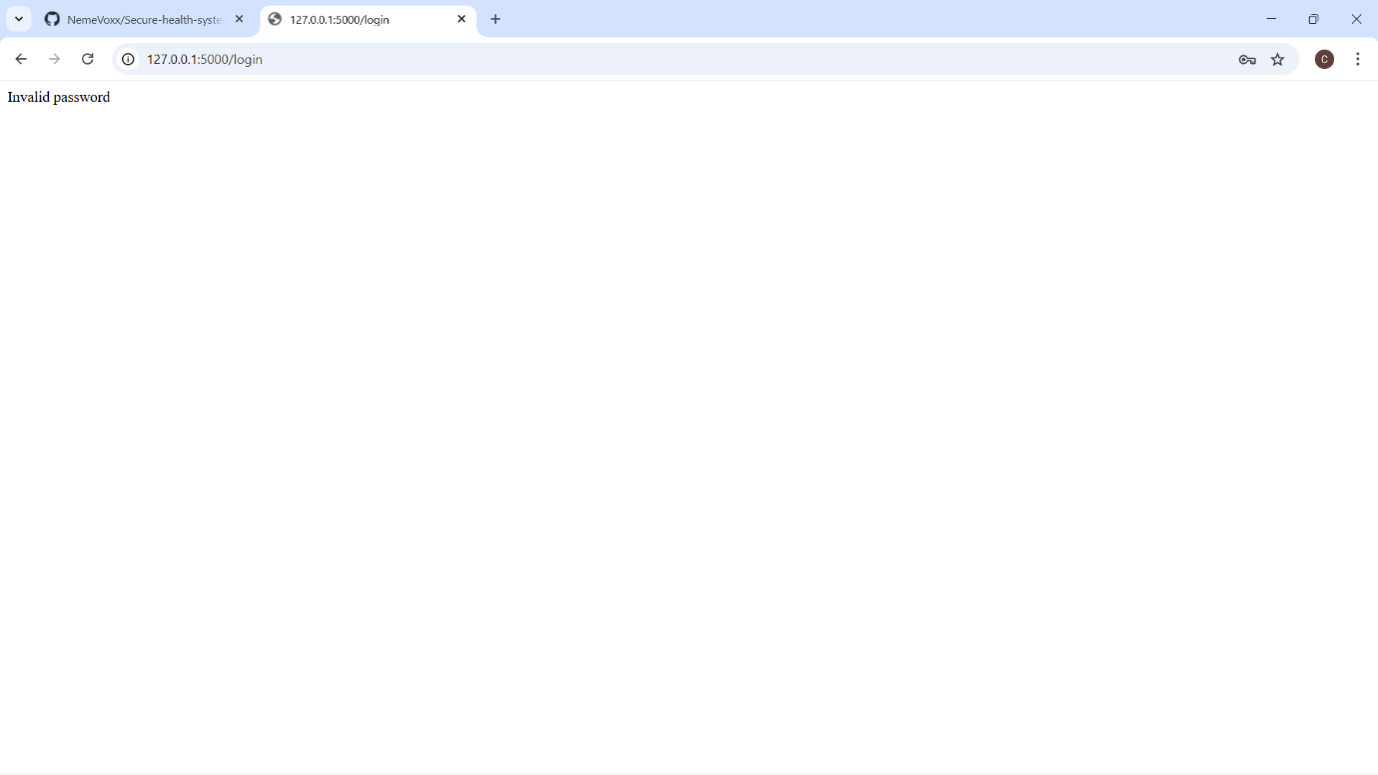
These tests show that authentication and session control are working.

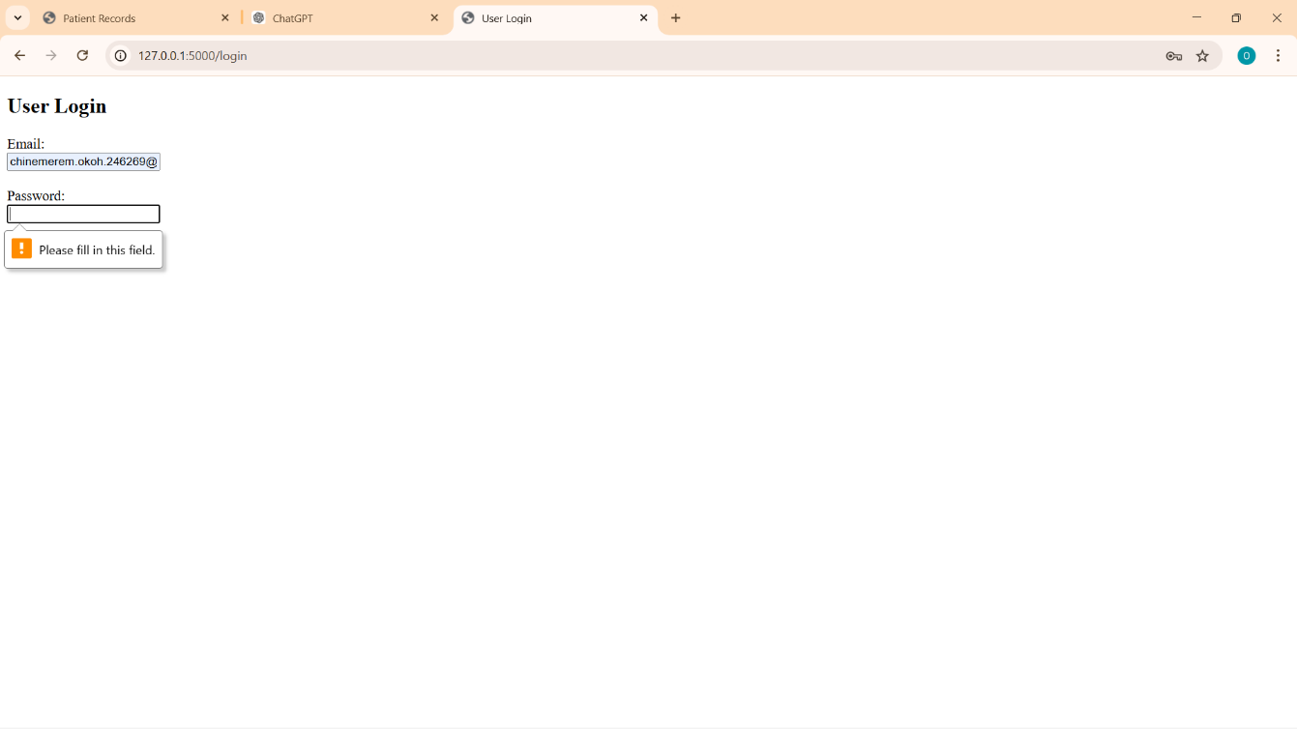

Version Control and GitHub
Version control was used during the development of this project to manage changes and track progress. Git was used to keep track of updates made to the system. This allows changes to be recorded and helps in managing different stages of development. Using version control is important in secure software development because it helps maintain a clear history of changes and reduces the risk of errors.
The project was uploaded to GitHub to demonstrate professional development practice.
The repository includes:
- Application source code
- HTML templates
- Project structure
- README file
Sensitive files, such as the database file and virtual environment, were excluded using a .gitignore file. This is important because uploading sensitive data can create security risks. Multiple commits were made during development to show progress. Each commit represents a change or improvement in the system, such as:
Using multiple commits shows that the system was developed step by step rather than all at once. My github link is https://github.com/NemeVoxx/Secure-health-system.git
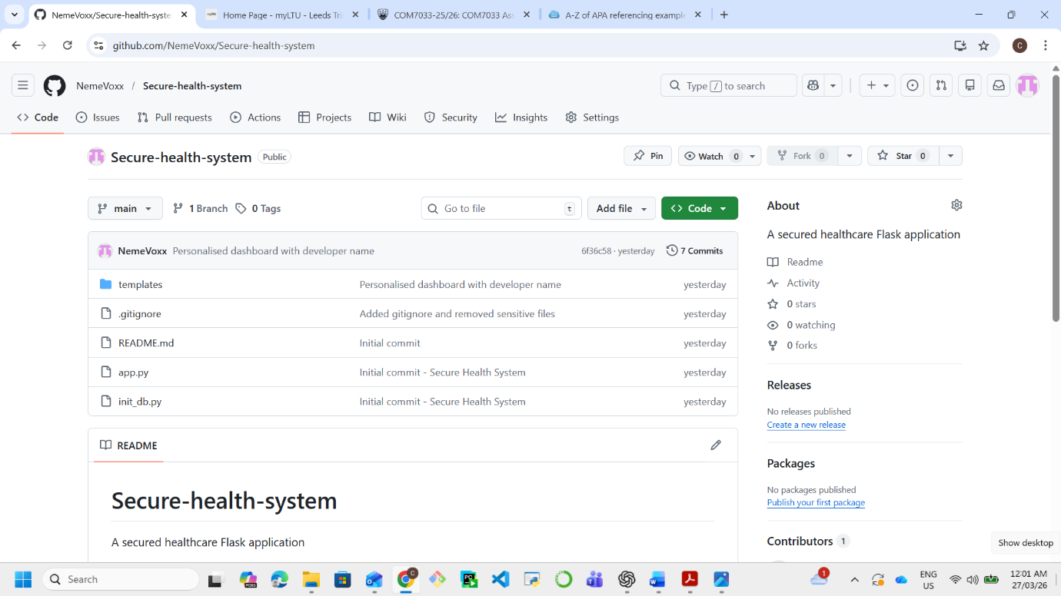

Conclusion
This project involved building a simple healthcare system that can store and manage patient records. The system allows users to log in and carry out basic tasks such as adding, editing, and deleting patient information. During the development, I focused on making sure the system was not just working, but also secure. For example, login was required before accessing the system, passwords were hashed, and user sessions were used to control access. These steps helped to reduce the risk of unauthorised access to patient data.
Using the STRIDE model also helped me understand the different types of threats that can affect a system like this, such as unauthorised login or data being changed. This made it easier to think about how security should be included during development, not just after.
Even though the system is simple, it shows the basic idea of secure software development. There are still improvements that could be made, such as adding different user roles, stronger validation, and better data protection. These would make the system more suitable for a real healthcare environment.

AI Declaration
This assignment used generative AI in the following ways for the purposes of completing the assignment): brainstorming, planning, rephrasing and editing.

References
Anderson, R. (2020). Security engineering: A guide to building dependable distributed systems (3rd ed.). Wiley.
European Union. (2018). General Data Protection Regulation (GDPR). https://gdpr.eu/

